**quality factor**

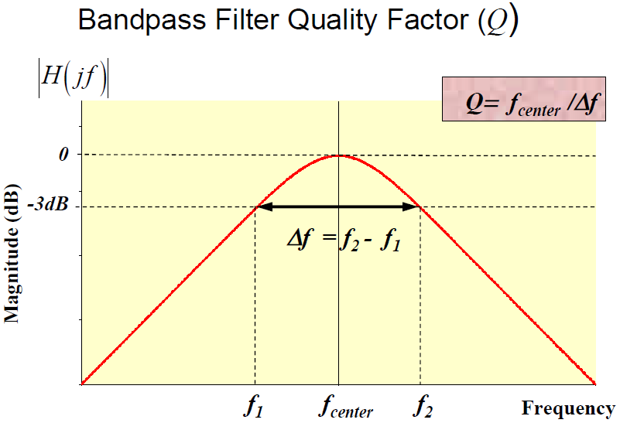

**Group Delay**

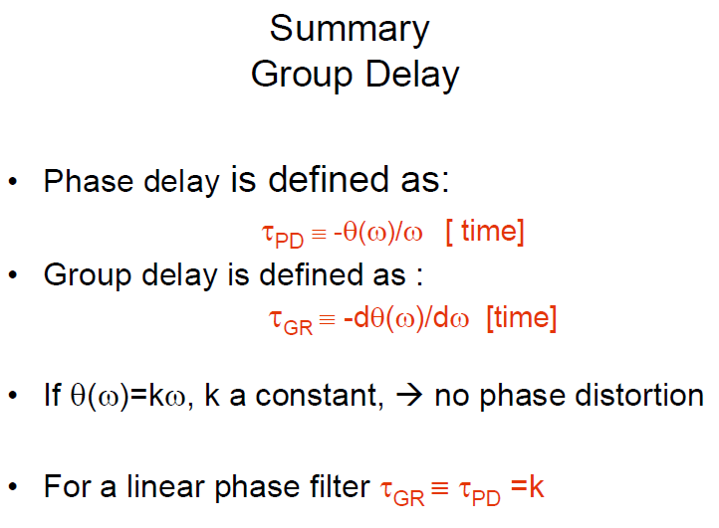

The distribution of the zeros and poles on the s plane tell us many things about the filter. **In order to have stability, all poles must be in the left side of the plane. If we have a zero at the origin, that is a zero in the numerator, the filter will have no response at dc (high-pass or band-pass)**

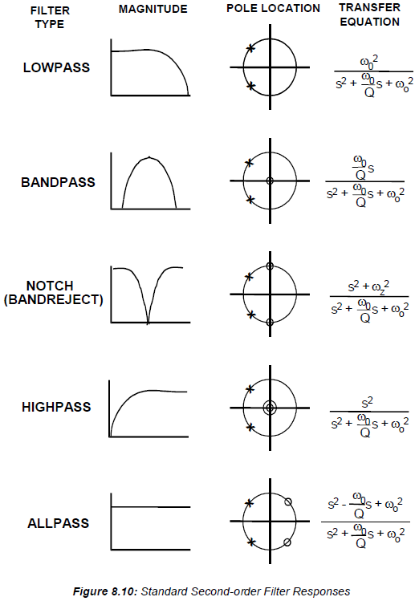

 is the cutoff frequency of the filter, 

 is the quality factor of the filter

**low-pass prototype**



**high-pass prototype**



**band-pass prototype**



where  is the center frequency and  has a particular meaning for the band-pass response. It is the selectivity of the filter, which is defined as



where  and  are the frequencies where the response is -3dB from the maximum.





**standard form of second-order low-pass filter**



where  is the cutoff frequency,  is the frequency scaling factor, and  is the quality factor.

if , 

The circuit passes signals multiplied by the gain factor .

if , 

signals are phase-shifted  and attenuated by the square of the frequency ratio.

if , 

signals are phase-shifted  and modified by the  factor.



**second-order low-pass Butterworth filter**







so that , 

**second-order low-pass Bessel filter**







so that , 







**cascading filter stages**

The concept of cascading second-order filter stages to realize higher-order filters is illustrated

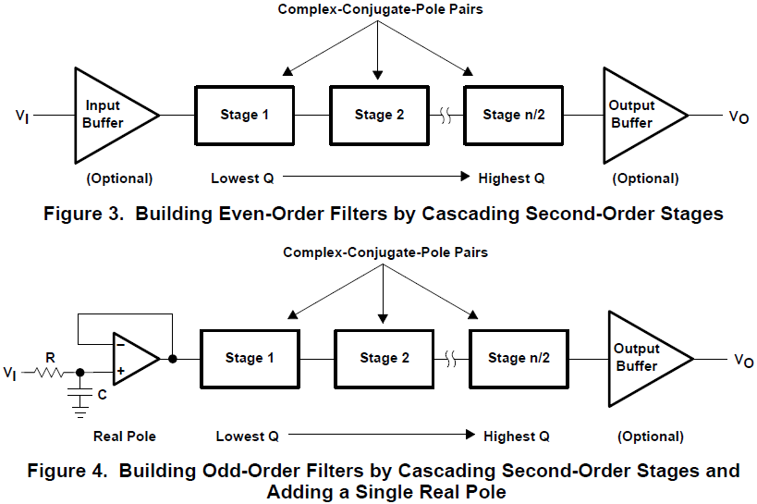

Theoretically, the order of the stages makes no difference, but to help avoid saturation, the stages are normally arranged with the lowest Q near the input and the highest Q near the output.

**Butterworth filter**

Butterworth filter is a type of signal processing filter designed to have a frequency response that is as flat as possible in the passband. It is also referred to as a **maximally flat magnitude** filter.

The Butterworth filter is the best compromise between attenuation and phase response. It has no ripple in the pass band or the stop band, and because of this is sometimes called a maximally flat filter. The Butterworth filter achieves its flatness at the expense of a relatively wide transition region from pass band to stop band, with average transient characteristics.

The pole positions are given by

, 

where  is the pole pair number, and  is the number of poles.

The poles are spaced equidistant on the unit circle, which means the angles between the poles are equal.

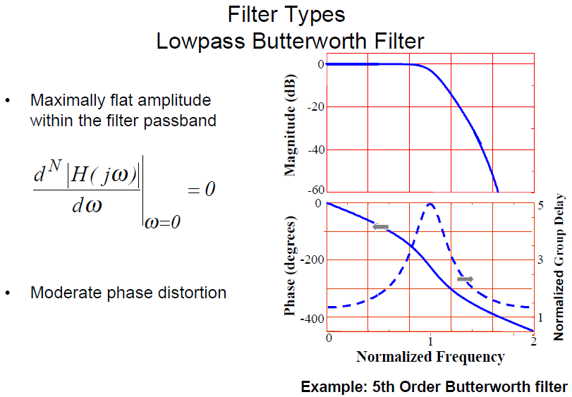

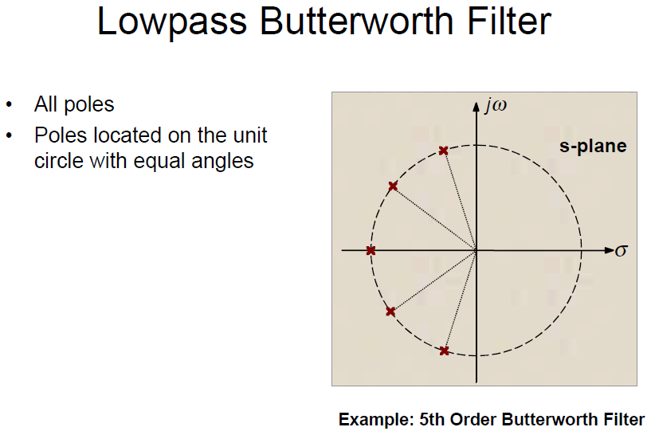

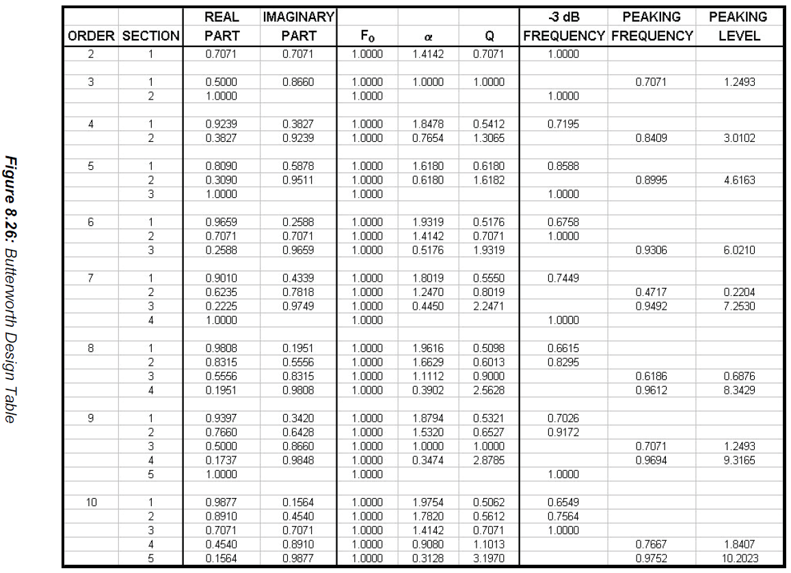

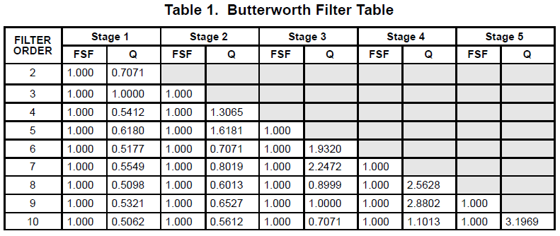

**Bessel filter**

Butterworth filters have fairly good amplitude and transient behavior. The Chebyshev filters improve on the amplitude response at the expense of transient behavior. The Bessel filter is optimized to obtain better transient response due to a linear phase (i.e, constant group delay) in the passband. This means that there will be relatively poorer frequency response.

The poles of the Bessel filter can be determined by locating all of the poles on a circle and separating their imaginary parts by , where  is the number of poles. Note that the top and bottom poles are distanced by where the circle crosses the  axis by  or half the distance between the other poles.

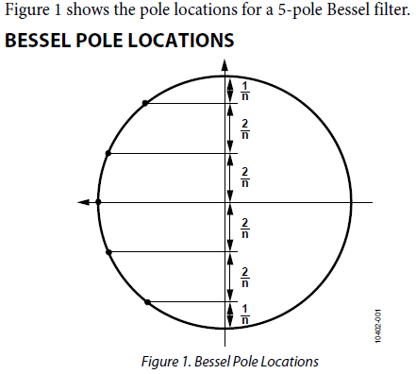

, where  is the actual pole of the Bessel filter, and  is the pole on the circle.

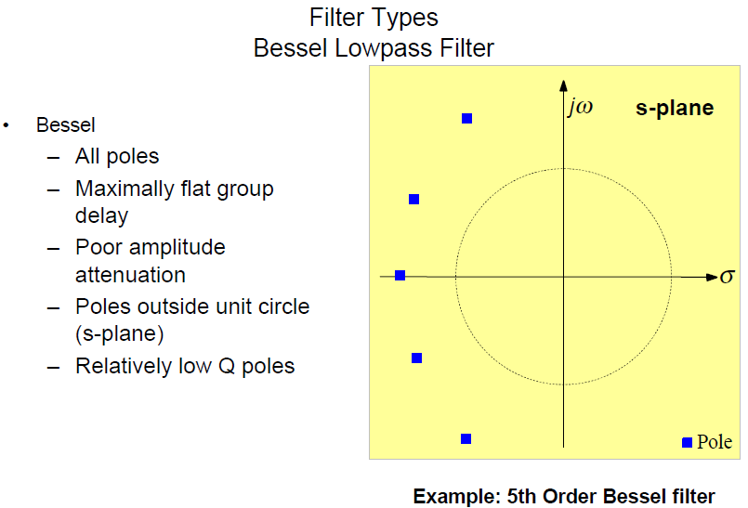

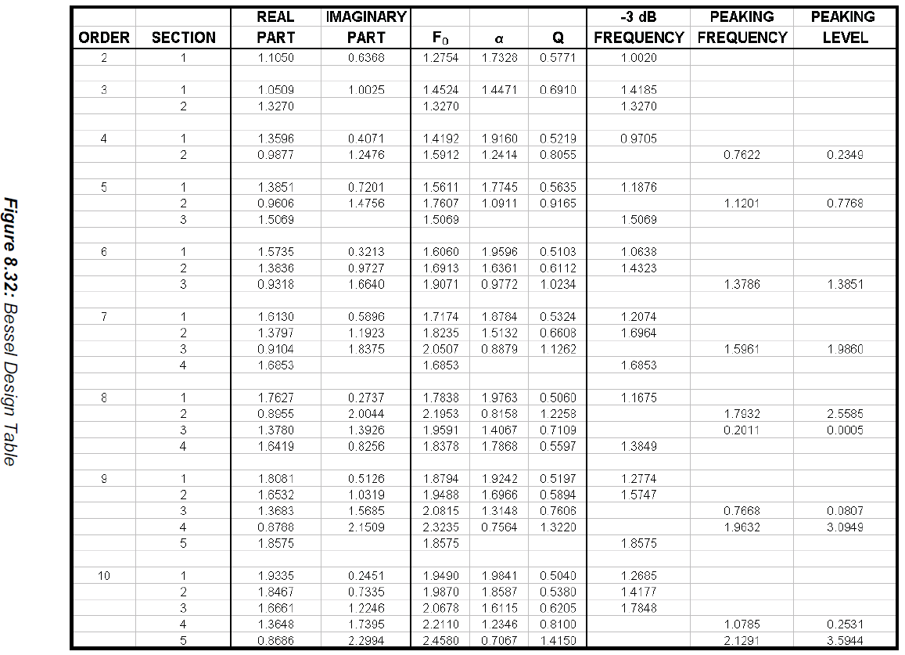

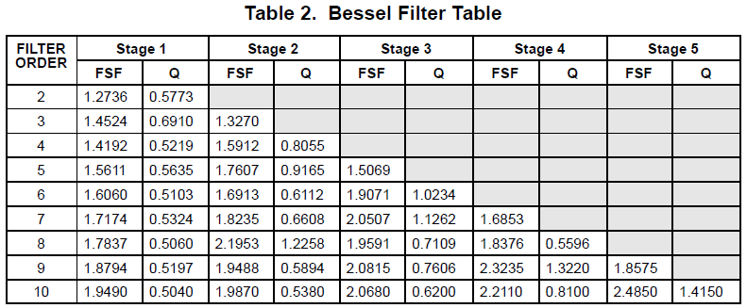

**low-pass single-pole IIR digital filter**

A low-pass single-pole IIR filter has a single design parameter, which is the **decay value** . It is customary to define parameters  and . For a typical value of , we have that  and . The recurrence relation is then given by





The recurrence relation directly shows the effect of the filter. **The previous output value of the filter  is decreased with the decay factor . The current input value  is taken into account by adding a small fraction  of it to the output of the filter**.

Substituting  into the given recurrence relation and rewriting leads to the expression





**The response of this filter is completely analogous to the response of an electronic low-pass filter consisting of a single resistor and a single capacitor**.

The decay value  is related to the time constant  (**in samples for the discrete case**) of the filter with the relation



Hence, if  is given, the value of  can be computed as



Another useful relation is that between  and the (-3dB) cutoff frequency , which is





**IIR digital filter structure**



**Direct-Form I (DF-I)**

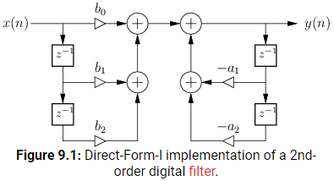

The DF-I structure has the following properties:

1. It can be regarded as a two-zero filter section followed by in series by a two-pole filter section.

2. The DF-I implementation cannot overflow internally in two’s complement fixed-point arithmetic: as long as the output signal in range, the filter will be free of numerical overflow.

3. There are twice as many delays as are necessary. As a result, the DF-I structure is not canonical with respect to delay. In general, it is always possible to implement an Nth-order filter using only N delay elements.

4. As is the case with all direct-form filter structures, the filter poles and zeros can be very sensitive to round-off errors in the filter coefficients. However, this is usually not a problem for a simple second-order section. To minimize this sensitivity, it is common to factor filter transfer function into series and/or parallel second-order sections.

**Direct-Form II (DF-II)**

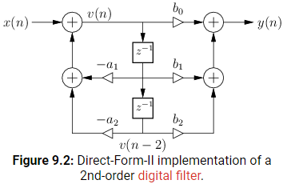





The DF-II structure has the following properties:

1. It can be regarded as a two-pole filter section followed by a two-zero filter section.

2. It is canonical with respect to delay. This happens because delay elements associated with the two-pole and two-zero sections are shared.

3. In fixed-point arithmetic, overflow can occur at the delay-line input, unlike in the DF-I implementation.

4. As with all direct-form filter structures, the poles and zeros are sensitive to round-off errors in the coefficients  and , especially for high transfer-function orders. Lower sensitivity is obtained using series low-order sections (e.g., second order), or by using ladder or lattice filter structure.

**Transposed Direct-Form I (TDF-I)**

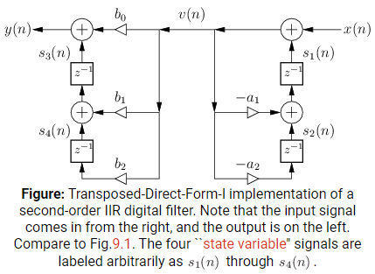

**Transposed Direct-Form II (TDF-II) (widely used)**

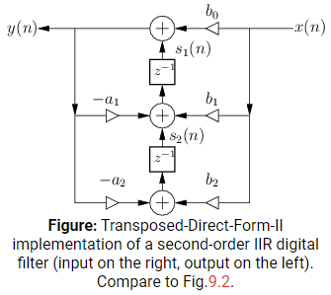





An advantage of the TDF-II structure is the zeros effectively precede the poles in series order. In many digital filters design, the poles by themselves give a large gain at some frequencies, and the zeros often provide compensating attenuation.

**Bilinear z-transform**

One of the most effective and widely used techniques for converting an analogue filter into a digital equivalent is by means of the bilinear z-transform.

Design a digital filter equivalent of a 2nd order Butterworth low-pass filter with a cut-off frequency  and a sampling frequency . Given that the analogue prototype of the frequency-domain transfer function  for a 2nd order Butterworth low-pass filter is



where the quality factor . The normalized cut-off frequency of the digital filter is given by



Now determine the equivalent analogue filter cut-off frequency  using the pre-warping function, that is



Now denormalize the frequency-domain transfer function  of the 2nd Butterworth filter, with the corresponding low-pass to low-pass frequency transformation (). Hence the denormalized transfer function of the **2nd low-pass Butterworth filter** becomes



Next, convert the analogue filter into an equivalent digital filter by applying the bilinear z-transform





,,

,

**second-order low-pass Butterworth filter:**













**second-order low-pass digital filter:**



















Alternatively denormalize the frequency-domain transfer function  of the 2nd Butterworth filter, with the corresponding low-pass to high-pass frequency transformation (). Hence the denormalized transfer function of the **2nd high-pass Butterworth filter** becomes



Next, convert the analogue filter into an equivalent digital filter by applying the bilinear z-transform





,,

,

**second-order high-pass Butterworth filter:**













**second-order high-pass digital filter:**



















**second-order band-pass Butterworth filter:**

 is center frequency

 is quality factor 















**second-order band-pass digital filter:**

 is center frequency

 is bandwidth

















**second-order band-stop Butterworth filter:**

 is center frequency

 is quality factor 















**second-order band-stop digital filter:**

 is center frequency

 is bandwidth

















**Linkwitz-Riley (L-R) filter**

L-R filter is known as Butterworth squared filter. The filter are usually designed by cascading two Butterworth filters, each of which has -3dB gain at the cut-off frequency. The resulting L-R filter has -6dB gain at the cut-off frequency.

A L-R crossover consists of a parallel combination of a low-pass and a high-pass L-R filter. Upon summing the low-pass and high-pass outputs, the gain at the crossover frequency will be 0dB. So the crossover behaves like an all-pass filter, having a flat amplitude response with a smoothly changing phase response. This is the biggest advantage of L-R crossovers compared to even-order Butterworth crossovers, whose summed output has a +3dB peak around the crossover frequency.

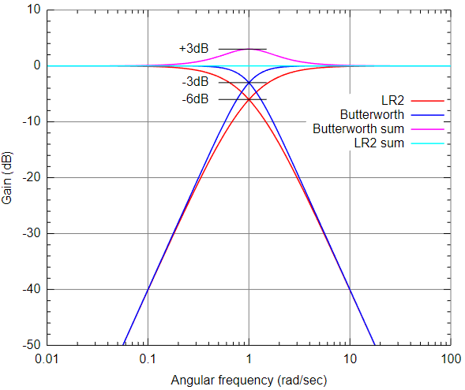











 is fourth-order Linkwitz-Riley low-pass filter

 is fourth-order Linkwitz-Riley high-pass filter

 is a all-pass filter

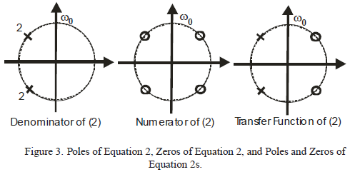





























**second-order Linkwitz-Riley low-pass filter:**



















**second-order Linkwitz-Riley high-pass filter:**



















**Shelving EQ**

Shelving EQ utilizes high and/or low shelf filters to **affect all frequencies above or below a certain cutoff frequency**, respectively. Shelving can be used to either boost/amplify or cut/attenuate and affects all frequencies equally beyond defined cutoff frequency points.

Shelving EQ is often listed as it’s own type of audio equalizer. These EQs are technically restricted to having **only low and high shelf controls** and you will typically only ever have them in **tone controls**. To limit things even further, these tone controls will only have **“bass” (low shelf)** and **“treble” (high shelf)** controls.

Low shelf filter can effectively increase or decrease the energy of the low-end without completely eliminating frequency content from the signal.

A low-shelf boost looks similar to a low-pass filter except the facts that:

1. the low-end is amplified

2. the amplitude levels out past f2 rather than continuing to roll-off

**A low shelf boost can be thought of as the summing of a dry (unfiltered) signal and that same signal affected by a low-pass filter**.

**A low shelf cut can be thought of as the summing of a dry (unfiltered) signal and that same signal affected by a high-pass filter** and then bringing down the overall amplitude to match the original signal’s amplitude above f2.

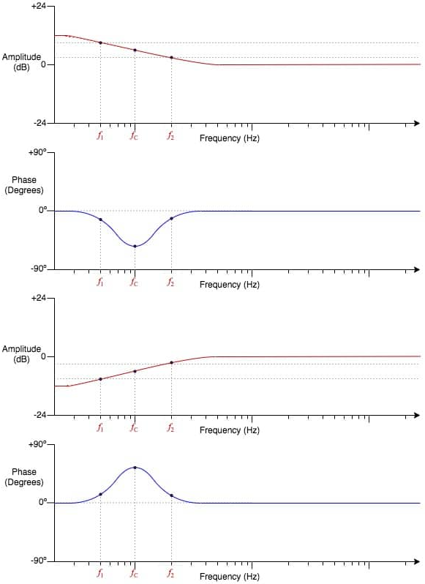

In the above graphs, we are dealing with first-order shelving filters (6 dB/octave slopes, ). The phase-shift is at a maximum (negative) at the centre frequency of the low shelf boost and at a maximum (positive) at the centre frequency of the low shelf cut. The phase-shift is not quite 90°either way.

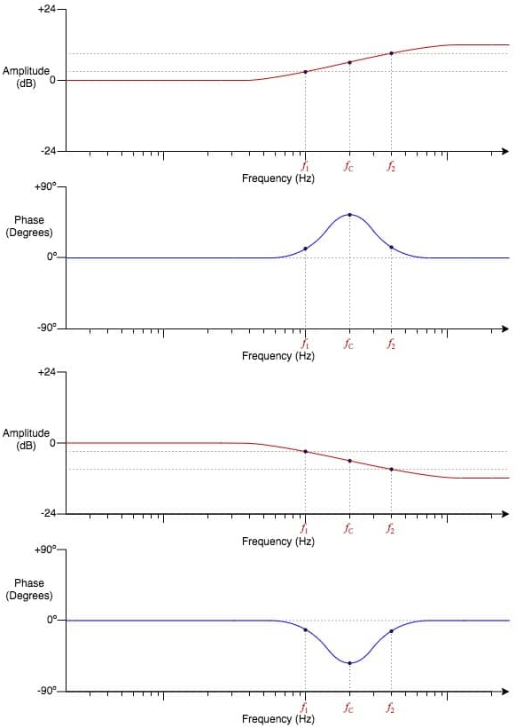

In the above graphs, we are dealing with first-order shelving filters (6 dB/octave slopes, ). The phase-shift is at a maximum (positive) at the centre frequency of the high shelf boost and at a maximum (negative) at the centre frequency of the high shelf cut. The phase-shift is not quite 90°either way.

**Two-pole shelf filter**

The transfer function of **second-order low shelf filter** in the s-plane is given by



where  ,  is quality factor.

The bilinear transform (with compensation for frequency warping) substitutes:



and make use of these trig identities:





Given a biquad transfer function defined as:



or















where ,  is the shelf midpoint frequency;  or ,  is shelf slope, when , the shelf slope is as steep as it can be.

The transfer function of **second-order high shelf filter** in the s-plane is the inverse of the low shelf transfer function, which is given by



where  ,  is quality factor.

Given a biquad transfer function defined as:



or















where ,  is the shelf midpoint frequency;  or ,  is shelf slope, when , the shelf slope is as steep as it can be.